“TempleSense AI: Temple Crowd-Level Prediction Using Tamil Calendar Feature Engineering and a Random Forest Classifier”
SARAN KARTHICK A  COMPUTER SCIENCE AND ENGINEERING  RAJALAKSHMI ENGINEERING COLLEGE  CHENNAI, INDIA  Roll No. 2116240701477 | SANTHOS SV  COMPUTER SCIENCE AND ENGINEERING  RAJALAKSHMI ENGINEERING COLLEGE  CHENNAI, INDIA  Roll No. 2116240701472

Abstract—Temples in Tamil Nadu receive highly uneven footfall. Weekends, festivals, public holidays and auspicious lunar days such as Amavasai, Pournami, Pradosham and Ekadasi can multiply the number of devotees several times, yet devotees have no dependable way to know how crowded a temple will be before they travel. This paper proposes TempleSense AI, a supervised machine-learning system that predicts the crowd level of a temple on a given date as one of four classes (Low, Moderate, High, Very High) and converts the prediction into a best visiting time, an expected waiting time and a travel tip. Tamil month, approximate lunar-day flags, festival and festival-proximity flags, holiday context and weather are engineered alongside calendar features, giving 19 inputs per record. A Random Forest classifier is trained on a seeded synthetic dataset of 34,680 daily records covering 20 temples in 12 districts (January 2022 to September 2026) using a stratified 80/20 split. It achieves 76.4% accuracy and a weighted F1-score of 76.4% on 6,936 unseen records and 76.2% ± 0.6% under five-fold cross-validation, outperforming K-Nearest Neighbours (62.9%) and Logistic Regression (60.0%) and matching a single Decision Tree (76.4%) while giving smoother class probabilities. Only 21 of 6,936 test records (0.3%) were placed two or more levels from the true class, and no Very High record was predicted as Low. The model is served through a Flask API and an interactive dashboard, and 16 automated tests pass. Because the data is synthetic, the results demonstrate the correctness of the end-to-end pipeline and not real-world forecasting accuracy.
Keywords—Crowd Prediction, Random Forest, Supervised Classification, Feature Engineering, Tamil Calendar, Recommendation System, Flask.
I. Introduction
Tamil Nadu is home to thousands of temples, and several of them, such as Meenakshi Amman at Madurai, Ramanathaswamy at Rameswaram, Srirangam, Arunachaleswarar at Tiruvannamalai and Palani Murugan, receive very large numbers of devotees every day. Footfall is far from uniform: it rises on weekends, school holidays, public holidays and long weekends, and on days of religious significance in the Tamil calendar. A devotee planning a visit currently relies on word of mouth or memory of earlier visits, which are unreliable, and the result is long queues and a diminished experience of worship.
Crowd behaviour is not random; it is driven by a recognisable set of recurring factors. A machine-learning model that has seen how these factors combined on past days can estimate the crowd on a future day. This work applies that idea to temples, moving a temple-information service from a purely descriptive one to a predictive and recommendation-driven one.
A. Need for the System
Existing temple websites present static information such as timings, history and maps, and do not forecast crowds. Manual planning is memory-dependent and unsystematic. Sensing-based solutions such as CCTV or IoT counters give live information but need hardware and data-sharing arrangements with each temple. A system that needs only historical records and calendar knowledge can serve temples where no sensing infrastructure exists.
B. Aim and Objectives
The aim is to develop an intelligent system that predicts the crowd level of a temple on a chosen date and recommends when to visit. The objectives are to:
- formulate temple crowd forecasting as a supervised four-class classification problem;
- engineer culturally specific features (Tamil month, Amavasai, Pournami, Pradosham, Ekadasi and temple festivals) alongside holiday and weather features;
- train and compare Random Forest, Decision Tree, K-Nearest Neighbours and Logistic Regression classifiers using accuracy, precision, recall, F1-score, confusion matrix and cross-validation;
- build a rule-based layer that maps the predicted class to a best time, waiting time and travel tip; and
- deploy the model behind a Flask API and a dashboard usable by non-technical devotees.
C. Scope
The project covers dataset preparation, feature engineering, model training and evaluation, the recommendation logic, a web dashboard with temple search, district filter and date selection, and automated testing for 20 temples in 12 districts. It does not cover real-time crowd sensing, live GPS tracking, ticket booking or a native mobile application. The dataset is synthetic and the lunar-day features are astronomical approximations.
D. Design Characteristics
The design emphasises a single shared feature module so that encoding is identical in training and serving; reproducible, seeded data generation; model comparison on one fixed split; probabilistic output shown as confidence bars; and a knowledge-based recommendation layer that turns a class label into an actionable decision.
E. Organization of the Paper
Section II reviews the literature, Section III presents the system architecture, Section IV describes the modules, dataset and model, Section V covers implementation and results, Section VI discusses the findings, and Section VII concludes with future work.
II. Literature Survey
The literature identifies several established techniques that form the conceptual basis of the proposed system (Table I).
Area | Approach
Crowd forecasting | Time-series models, feature-based machine learning and sensing-based counting
Supervised classification | Learning a mapping from labelled examples to categories [3], [4]
Ensemble learning | Random Forest: bootstrap-sampled trees with random feature subsets, combined by voting [1]
Evaluation | Precision, recall, F1-score, confusion matrix and cross-validation [5], [11]
Class imbalance | Class weighting, resampling and SMOTE [10]
Table I: Approaches in the Literature
Crowd and Footfall Forecasting: Forecasting the number of people at a place and time is common in transport planning, retail, tourism and event management. Statistical time-series models work when a long, regular history of counts exists. Sensing-based systems give live information but need hardware. Feature-based machine learning sits between the two: it needs only historical records and calendar knowledge.
Supervised Learning: A model is trained on examples with known outputs and then predicts the output for new inputs [3], [4]. Temple crowd level is an ordered categorical variable with four values, so multi-class classification is appropriate. Performance is judged on unseen data using a held-out test set and cross-validation [5].
Decision Trees and Random Forests: A decision tree classifies an example by asking a sequence of questions about its features, but a single deep tree tends to overfit. A Random Forest builds many trees on bootstrap samples with a random subset of features at each split and combines their votes [1]. Averaging de-correlated trees reduces variance and yields feature-importance scores, which suits tabular, mixed-type data.
Evaluation Measures: Accuracy alone can mislead when classes are imbalanced, as the Very High class is here. Precision, recall, F1-score and the confusion matrix show which classes are confused [11]. Because crowd levels are ordered, it is also informative to check whether errors fall between neighbouring levels.
Research Gap: Existing temple websites do not forecast crowds, and general crowd-forecasting work does not account for the Tamil lunar calendar, whose auspicious days do not fall on fixed Gregorian dates. The proposed system encodes Tamil-calendar and festival features explicitly and links the prediction to a recommendation a devotee can act on.
III. System Architecture
The system follows a layered pipeline. The devotee selects a temple and a date. The backend converts them into a feature vector, the trained Random Forest predicts the crowd level, the recommendation logic turns the prediction into advice, and the Flask API returns the result as JSON to the dashboard (Fig. 1). Training is offline: the dataset is cleaned and encoded, split into training and test sets, and used to fit the model, which is saved with joblib and loaded once at application start-up.
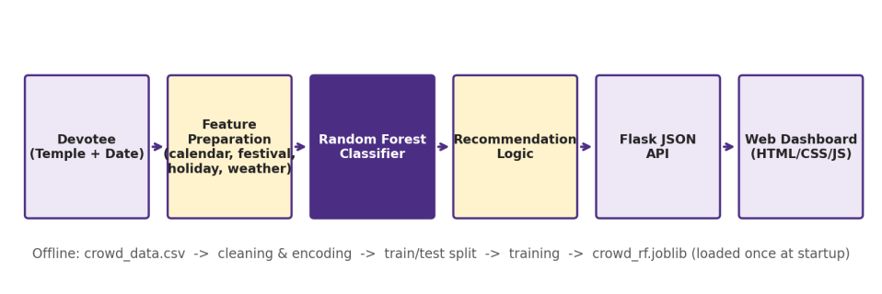
Fig. 1: System architecture of TempleSense AI
A. Intelligent Agent View (PEAS)
The system can be described as a goal-based, utility-oriented software agent in the sense of Russell and Norvig [3] (Table II).
Element | Description
Performance measure | Classification accuracy, F1-score, usefulness of the recommendation (shorter waiting)
Environment | Temples, calendar (Tamil month, lunar days, festivals), holidays, weather
Actuators | Dashboard output: crowd level, best time, waiting time, travel tip, seven-day outlook
Sensors | User input (temple and date) and stored datasets (CSV files)
Table II: PEAS Description of the Agent
B. Data Flow
At Level 0 the system is a single process that accepts a temple name and a date and returns a prediction, a recommendation and temple information. At Level 1 it splits into five stages: input handling, which validates the temple and date; feature assembly, which derives the calendar, lunar, festival, holiday and expected-weather features; model inference; recommendation generation; and response assembly as JSON.
C. System Modules
Module | Responsibility
Crowd Prediction | Builds the feature vector; returns class and class probabilities
Recommendation | Maps each level to time window, waiting time and travel tip
Tamil Calendar | Derives Tamil month, tithi flags and festivals
Holiday Analysis | Flags public holidays, school holidays and long weekends
Weather Analysis | Supplies season, expected weather, temperature and rainfall
Temple Information | Provides district, deity, festivals and a map link
Dashboard | Search, filter, date selection, probability bars, seven-day outlook
Table III: Modules of the System
IV. Modules
A. Dataset Module
Four CSV files are produced by a generator script: temples (20 temples with district, deity type and popularity), festival calendar, holidays, and the main training file crowd_data.csv. The main file contains 34,680 rows, one per temple per day, from 1 January 2022 to 30 September 2026. The temples include Meenakshi Amman (Madurai), Brihadeeswarar (Thanjavur), Ramanathaswamy (Ramanathapuram), Srirangam Ranganathaswamy (Tiruchirappalli), Arunachaleswarar (Tiruvannamalai), Kapaleeshwarar (Chennai), Palani Murugan (Dindigul) and Thiruchendur Murugan (Thoothukudi).
Real daily footfall records are not publicly available for these temples, so the data is synthetic and fully reproducible through a fixed random seed. For each temple and day, a crowd ratio is computed as the product of the temple’s base popularity and multipliers for weekends, public holidays, long weekends, school holidays, festivals (with an additional boost at temples for which the festival is special), festival proximity, Pournami, Amavasai, Pradosham and Ekadasi (for the relevant deity types), rain and high temperature, with log-normal random noise. The ratio is converted into one of four crowd levels. The classes are imbalanced: Low 40.2%, Moderate 29.5%, High 21.8% and Very High 8.5% (Fig. 2).
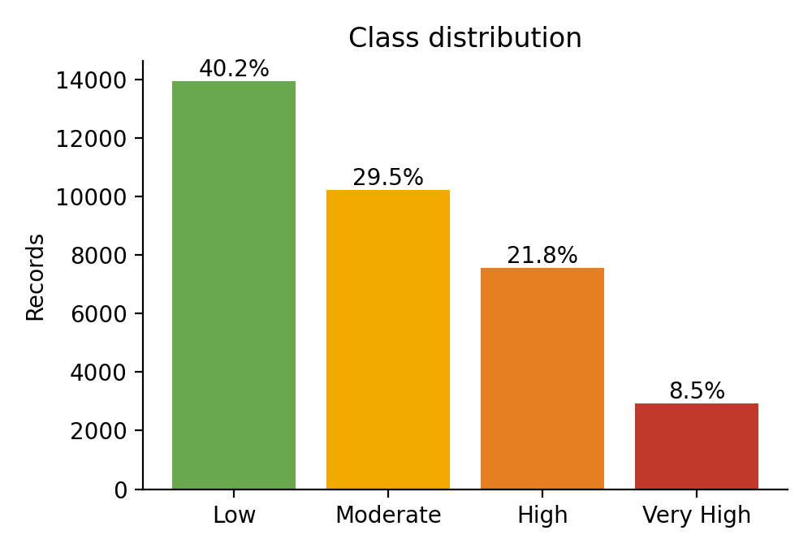
Fig. 2: Distribution of crowd levels in the dataset
B. Tamil Calendar and Festival Encoding Module
Tamil festivals do not fall on fixed Gregorian dates, so they are derived. The Tamil month is determined from the approximate dates on which the sun enters each zodiac sign (for example, Chithirai begins around 14 April). The lunar day (tithi) is computed from the age of the moon using a reference new moon and the mean synodic month of 29.53 days, dividing each lunar month into 30 tithis. Tithi 30 is taken as Amavasai, tithi 15 as Pournami, tithis 11 and 26 as Ekadasi, and tithis 13 and 28 as Pradosham. Named festivals are derived by combining month and tithi: Pournami in Chithirai is Chitra Pournami, in Thai is Thai Poosam, in Panguni is Panguni Uthiram and in Karthigai is Karthigai Deepam, while Ekadasi in Margazhi is Vaikunta Ekadasi. Pongal, Tamil New Year, Aadi Perukku, Deepavali and Vinayagar Chathurthi are added from fixed or tabulated dates. Unit tests confirm known dates such as Thai Poosam on 25 January 2024 and Chitra Pournami on 23 April 2024.
C. Feature Engineering Module
Each record is described by 19 features (Table IV). Categorical fields (temple, district, Tamil month, festival, weather, season) are label-encoded with fixed category lists defined in one module, so training and prediction use the same encoding; the encoder rejects unknown categories rather than silently mapping them. Weather is grouped into three categories (Sunny, Cloudy, Rainy) to reduce sparsity, and a composite long-weekend flag captures a holiday adjacent to a weekend.
Type | Features
Calendar | day_of_week, weekend, month, tamil_month, season
Lunar and festival | is_amavasai, is_pournami, is_ekadasi, is_pradosham, festival, festival_proximity
Holiday | public_holiday, school_holiday, long_weekend
Weather | weather, temperature, rainfall_mm
Location | temple, district
Table IV: Features Supplied to the Model (19 in Total)
D. Machine-Learning Module
A Random Forest classifier was chosen because the feature set mixes categorical and numerical variables, it needs little tuning, its ensemble resists overfitting on a dataset of moderate size, and it provides feature importances. To justify the choice, three other classifiers were trained on the same split: a single Decision Tree, K-Nearest Neighbours (k = 7, standardised features) and Logistic Regression (standardised features).
The workflow is data generation, cleaning and validation, feature engineering, label encoding, stratified 80/20 split, training, prediction and evaluation. The training set has 27,744 records and the test set 6,936, with random seed 42. The Random Forest uses 200 trees, min_samples_leaf = 3, max_features = 0.7 and unlimited depth. Very deep trees with a leaf size of one fitted the noise and gave slightly lower test accuracy, whereas a leaf size of three with 70% feature sampling gave the best result.
E. Recommendation Module
The recommendation layer is knowledge-based: it encodes simple expert rules on top of the learned prediction (Table V), so that the classifier output becomes a decision the devotee can act on.
Level | Best time | Waiting | Advice
Low | 10 AM–12 PM or 5–7 PM | 10–20 min | Calm day, ideal for darshan
Moderate | 6–8 AM or after 6:30 PM | 30–45 min | Avoid the late-morning rush
High | Before 6 AM or after 8 PM | 60–90 min | Expect queues, plan extra time
Very High | Before 5 AM or another date | 2–3 hours | Peak crowd, consider the lighter day
Table V: Mapping from Crowd Level to Advice
V. Implementation and Results
A. Experimental Setup
The backend is written in Python with Flask, using scikit-learn, pandas, NumPy and joblib. The route /api/predict accepts a temple name and a date (YYYY-MM-DD), validates them, derives and encodes the features, and obtains class probabilities from the Random Forest; the class with the highest probability is the prediction. The same call is repeated for the next six days to produce a seven-day outlook, and the day with the lowest predicted level is reported as the best day. The route /api/temples supports search by name and district filtering, and invalid inputs return HTTP 400 with a message. The frontend is a single HTML, CSS and JavaScript page that updates asynchronously (Figs. 6 and 7).
The machine-learning pipeline was evaluated on a held-out test set and with five-fold stratified cross-validation. The calendar logic, model wrapper and web API were verified with 16 unit and API tests written with Python’s unittest module, all of which passed. The metrics reported are accuracy, weighted precision, recall and F1-score, per-class scores and the confusion matrix (Table VI).
Element | Description
Language | Python 3.10+, HTML, CSS, JavaScript
Libraries | scikit-learn, pandas, NumPy, joblib, Matplotlib, Flask
Data | 34,680 records, 20 temples, 19 features, 4 classes
Split | Stratified 80/20 (27,744 train, 6,936 test), seed 42
Models | Random Forest, Decision Tree, KNN (k = 7), Logistic Regression
Metrics | Accuracy, precision, recall, F1, confusion matrix, 5-fold CV
Table VI: Experimental Setup
B. Results
The Random Forest reached 76.4% accuracy on the 6,936 unseen records, and five-fold cross-validation gave 76.2% with a standard deviation of 0.6 percentage points, indicating that the result does not depend on one lucky split (Table VII, Fig. 3).
Model | Acc. | Prec. | Rec. | F1
Random Forest | 76.4 | 76.4 | 76.4 | 76.4
Decision Tree | 76.4 | 76.4 | 76.4 | 76.3
KNN (k = 7) | 62.9 | 62.1 | 62.9 | 62.3
Logistic Regression | 60.0 | 59.1 | 60.0 | 59.1
Table VII: Test-Set Performance (Weighted Averages, %)
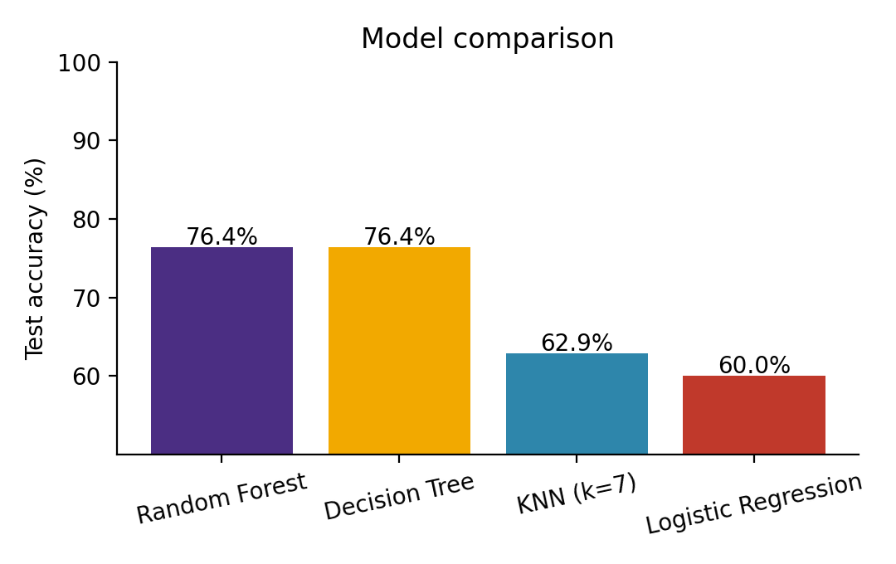
Fig. 3: Test accuracy of the four classifiers
The Random Forest and the Decision Tree are almost equal, which is expected because the data was generated from rules that a tree can recover; the forest is preferred for its stability and smoother probabilities. Both tree-based models are about 14 to 16 percentage points better than KNN and Logistic Regression, because the relationship between features and crowd is multiplicative and conditional (a festival matters more at a temple for which it is special) and cannot be expressed by a linear boundary.
Class | Prec. | Recall | F1 | Support
Low | 84.6 | 87.2 | 85.9 | 2790
Moderate | 66.3 | 66.0 | 66.1 | 2046
High | 72.1 | 71.1 | 71.6 | 1513
Very High | 83.1 | 75.3 | 79.0 | 587
Table VIII: Per-Class Results (Random Forest, %)
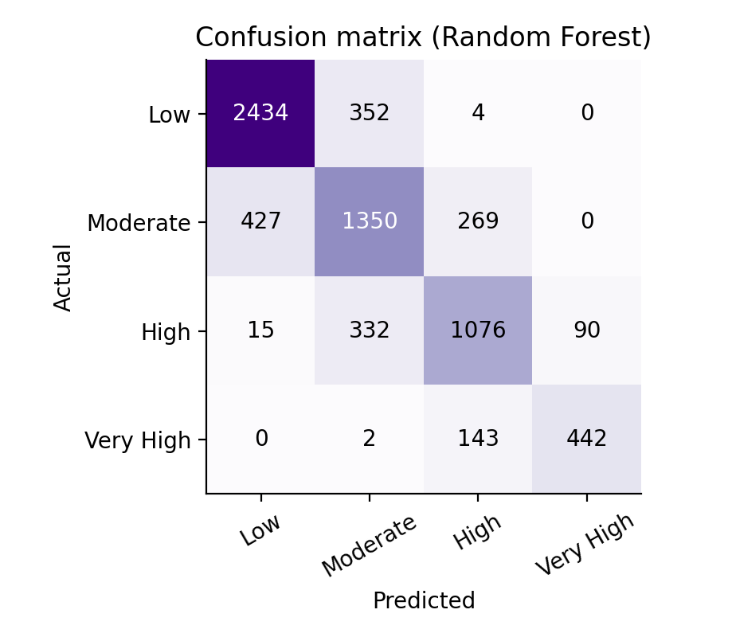
Fig. 4: Confusion matrix of the Random Forest
The extreme classes are recognised best (Low F1 85.9%, Very High F1 79.0%), and Moderate is hardest (F1 66.1%) because it lies between two neighbours. Errors are almost entirely between neighbouring levels: only 21 of 6,936 test records (0.3%) are placed two or more levels from the true class, and no Very High record was predicted as Low (Fig. 4). For a visitor, mistaking Moderate for High is a mild error, whereas mistaking Very High for Low would be a serious one, which the model avoids.
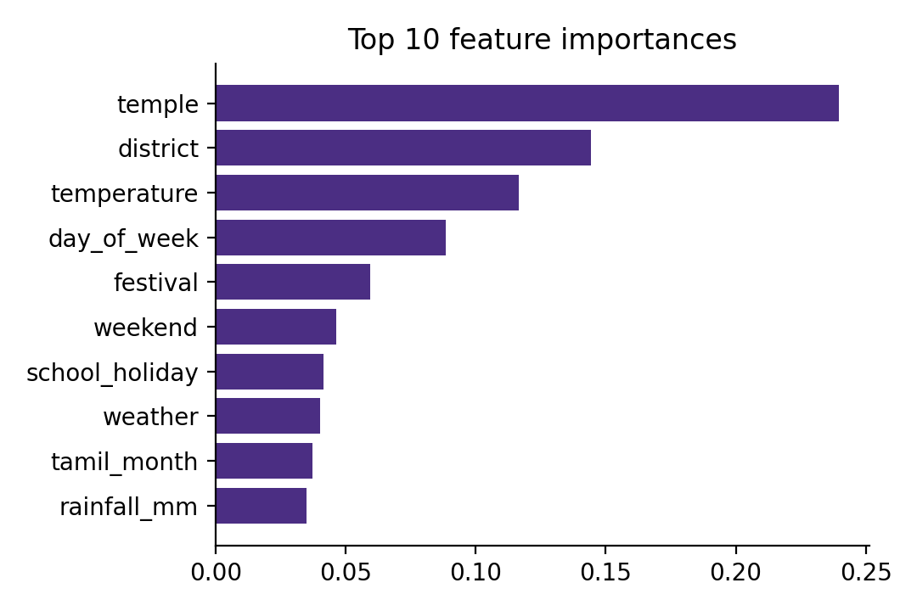
Fig. 5: Ten most important features of the Random Forest
The five most influential features are temple (24.0%), district (14.4%), temperature (11.7%), day of week (8.8%) and festival (6.0%) (Fig. 5). Temple and district rank highest because temples differ in popularity, and temperature ranks high partly because it varies with the season. Impurity-based importances favour features with many distinct values, so they describe the model’s behaviour and are not a causal ranking.
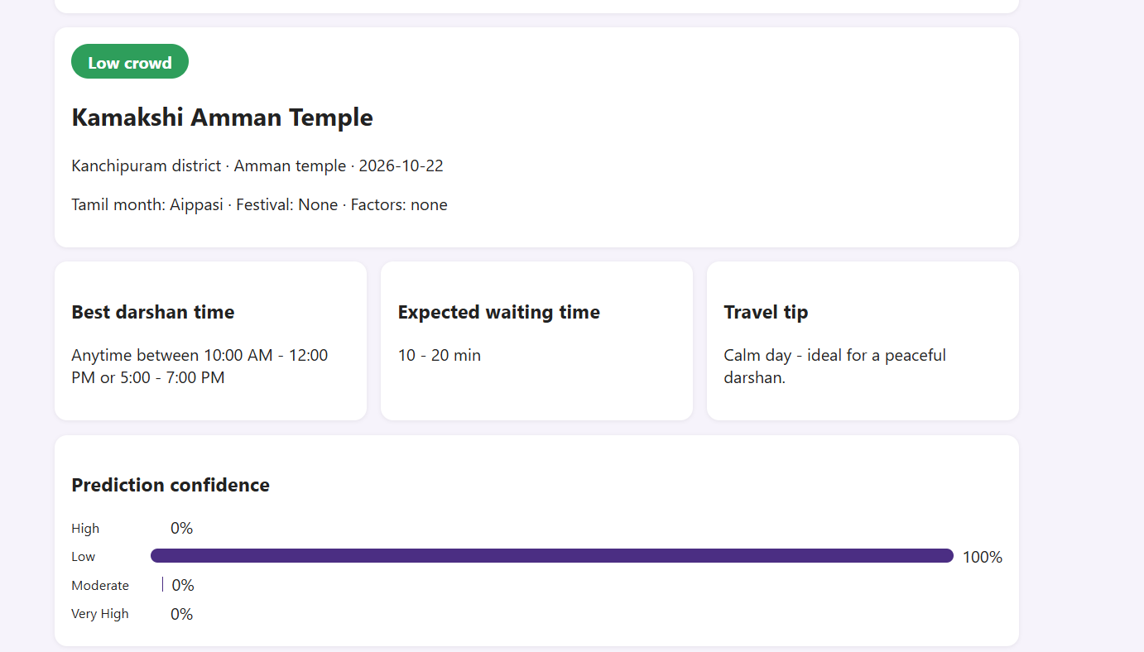
Fig. 6: Crowd prediction and darshan recommendations
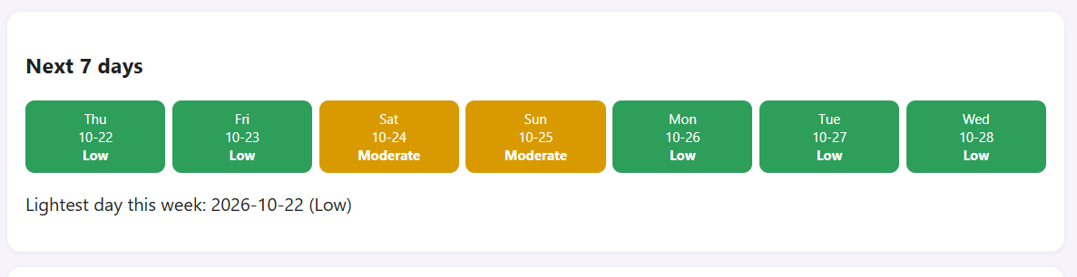
Fig. 7: Seven-day crowd forecast
C. Advantages, Limitations, and Applications
Advantages: a complete pipeline from data to dashboard; culturally specific features; probabilistic output; errors that stay between neighbouring levels; and easy extension by editing the temple list and feature module.
Limitations: the dataset is synthetic, so absolute accuracy says nothing about real temples; lunar-day features are approximations that can differ from the published Panchangam by a day; future weather is replaced by expected weather for the month; recommendation windows are typical values that should be confirmed with the temple; and Very High crowds are rare.
Applications: helping devotees plan visits, supporting temple administrators in staffing and queue management, and serving as a template for crowd prediction at other cultural or tourist sites.
VI. Discussion
A. Why a Random Forest
The data mixes categorical and numerical features and contains interactions, such as a festival mattering more at certain temples. Tree-based models capture such conditional effects directly, which explains their advantage over KNN and Logistic Regression. The forest equals the single tree in accuracy but averages many trees, giving more stable estimates and smoother probabilities for the confidence bars.
B. Meaning of the 76% Accuracy
The accuracy reflects the data more than the algorithm. The generator adds random noise to every record, and records whose true crowd ratio lies close to a class boundary cannot be classified perfectly by any model, which is consistent with the errors lying between adjacent classes. With real footfall records, the same code could be retrained and its accuracy re-measured.
C. Practical Considerations
Predictions are estimates, not guarantees. The output depends on the quality of the calendar approximation and, in deployment, on the realism of the training data, so the system should be read as a planning aid.
VII. Conclusion and Future Work
A. Conclusion
This paper presented TempleSense AI, which combines supervised classification, ensemble learning, Tamil-calendar feature engineering, probabilistic output and a knowledge-based recommendation layer to predict temple crowd levels and advise devotees. The Random Forest achieved 76.4% accuracy and a weighted F1-score of 76.4% on unseen data, outperformed KNN and Logistic Regression by a wide margin, and made its errors almost exclusively between neighbouring crowd levels. The model is served through a Flask API and an interactive dashboard. These results are measured on synthetic data and do not measure real-world accuracy.
B. Future Work
Future work includes training on real footfall data from temple administrations and re-evaluating accuracy; integrating live weather and official holiday APIs; combining the prediction with real-time CCTV or IoT counts; using time-series or deep-learning models such as LSTM; applying imbalance techniques such as SMOTE; adding Tamil-language support and a mobile application; extending coverage to more temples and states with a district-level heat map; integrating e-darshan and ticket booking; and cloud deployment. These are development directions, not results established by this work.
VIII. References
[1] L. Breiman, “Random Forests,” Machine Learning, vol. 45, no. 1, pp. 5–32, 2001.
[2] F. Pedregosa et al., “Scikit-learn: Machine Learning in Python,” Journal of Machine Learning Research, vol. 12, pp. 2825–2830, 2011.
[3] S. Russell and P. Norvig, Artificial Intelligence: A Modern Approach, 4th ed. Pearson, 2021.
[4] T. M. Mitchell, Machine Learning. McGraw-Hill, 1997.
[5] T. Hastie, R. Tibshirani and J. Friedman, The Elements of Statistical Learning, 2nd ed. Springer, 2009.
[6] W. McKinney, “Data Structures for Statistical Computing in Python,” in Proc. 9th Python in Science Conference, 2010, pp. 56–61.
[7] C. R. Harris et al., “Array programming with NumPy,” Nature, vol. 585, pp. 357–362, 2020.
[8] J. D. Hunter, “Matplotlib: A 2D Graphics Environment,” Computing in Science & Engineering, vol. 9, no. 3, pp. 90–95, 2007.
[9] Flask Documentation. [Online]. Available: https://flask.palletsprojects.com
[10] N. V. Chawla, K. W. Bowyer, L. O. Hall and W. P. Kegelmeyer, “SMOTE: Synthetic Minority Over-sampling Technique,” Journal of Artificial Intelligence Research, vol. 16, pp. 321–357, 2002.
[11] M. Sokolova and G. Lapalme, “A systematic analysis of performance measures for classification tasks,” Information Processing & Management, vol. 45, no. 4, pp. 427–437, 2009.

